Android Application Project

COM 437 Mobile Applications

Dustin Armstrong

Saint Leo University

1. Introduction
   1. Background:

Mobile Applications COM 437 provides the basics of mobile applications by learning the design and development of Android applications. As part of this course, I must design and develop an Android application.

* 1. Purpose of the project:

This project will demonstrate the skills learned throughout the course by completing a working Android application.

* 1. Scope of the project:

The requirement for the course is to develop a working Android application and demonstrate its use. We have eight weeks to complete the working Android application.

1. Project Description
   1. Overview of the project:

Android application that will help users keep track of their home maintenance tasks. The application will enable users to create a list of maintenance tasks, set assignment reminders, and track completed tasks. The dashboard will display the summary of completed tasks.

* 1. Objectives of the project:

By using this app, users will be able to manage their home maintenance tasks more efficiently and effectively.

* 1. Target Audience:

The target audience for this application are homeowners and property managers looking for a way to track home maintenance requirements.

* 1. Benefits of the project:

This application will provide a resource for creating maintenance tasks, setting assignment reminders, and tracking completed statuses.

1. Problem Addressing
   1. Identification of the problem:

Good homeownership or property management requires consistent upkeep and maintenance to ensure the house operates appropriately and lessens the likelihood of material breakdown or equipment malfunctions. This application will help ensure that the necessary care is adequately accomplished to keep the house running in the best condition possible.

* 1. Cause of the problem:

In many cases, for homeowners, there is a lack of awareness around the importance of specific tasks. This is especially true for functions that are not urgent. Another issue is that some owners are unaware of the frequency of maintenance required to keep a house in top condition.

* 1. Impact of the problem on the target audience:

Failure to perform certain maintenance items could result in unsafe conditions, costly repairs, and reduced property value.

1. Platform
   1. Selection of platform:

The application will be developed for the Android operating system, compatible with smartphones and tablets running Android version 6.0 or higher.

* 1. Explanation of the platform:

This platform is required for the course, and version 6.0 and higher is the version that most users support.

* 1. Advantages of the platform:

Google offers various services that developers can use to build applications. These services can help developers get help and support when needed. Google also has a large Android developer community that allows collaboration when required.

1. Front/Back End Support
   1. Selection of the front-end technology:

The front end of the application will be developed using Java and Android Studio

* 1. Selection of the back-end technology:

SQLite will support the back-end technology

1. Functionality
   1. List of features and functionalities
      1. Create and manage a list of maintenance tasks, including the task name, description, and frequency.
      2. Set assignment reminders based on the selected frequency, such as daily, weekly, monthly, or yearly.
      3. Track completed tasks and provide a history of tasks completed.
      4. Provide a dashboard showing a summary of completed, upcoming, and overdue tasks.
   2. Overall usage:

The application will provide push notifications to alert users of upcoming and late maintenance requirements.

1. Design (Wireframes)
   1. Overview of design
      1. Home Screen: This will be the first screen users will see upon opening the app. It will display the list of maintenance tasks and their status, including completed and overdue tasks.
      2. Task List: This screen will allow users to view an existing task in monththe list. For example, users can see the required maintenance for the week/month/year
      3. Individual Task: This screen will display the details of a selected task, including the task name, description, frequency, and notes/images attached to it
      4. Diagram Screen: This screen will display maintenance diagrams
      5. Maintenance Log: This screen will summarize completed tasks, upcoming tasks, and overdue tasks.

Wire Frame:

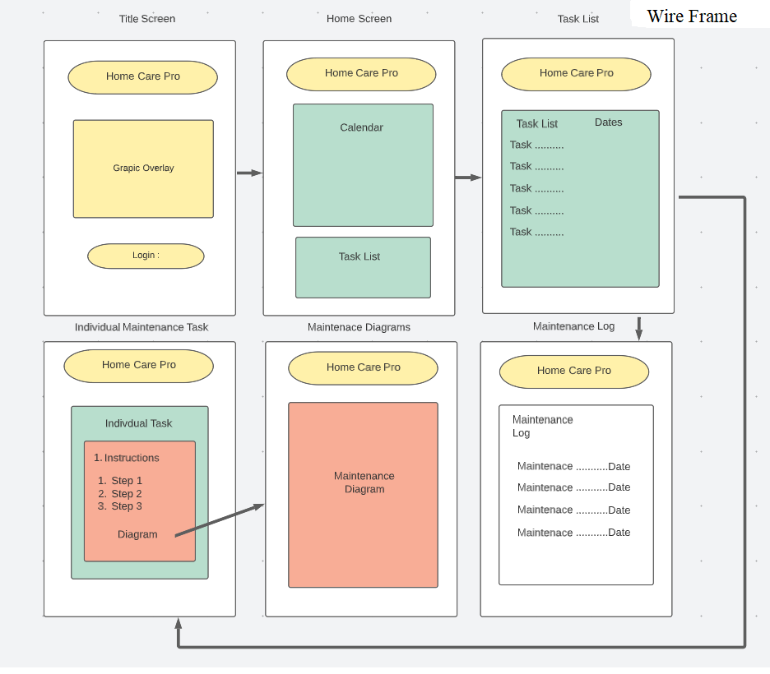

1. Conclusion
   1. Recap of the project:

The application will have a simple and user-friendly design, making it easy for users to manage their home maintenance tasks efficiently and effectively.

* 1. Future developments and enhancements:

Possible cross-platform scheduling

1. References
   1. List of sources used in the report
      1. *Android Studio & App Tools* Android Developers
      2. Realm.io
      3. Space Technologies.com
   2. Citations for each source
      1. *Android Studio & App Tools*. Android Developers. (n.d.). Retrieved April 14, 2023, from https://developer.android.com/studio?gclid=CjwKCAjw8-OhBhB5EiwADyoY1WD1peYxKDZ1HK5ZVV5tx4vLe7amHLG-RUY1M4g5NoYlRdH8mCEUvhoC_H4QAvD_BwE&gclsrc=aw.ds
      2. MongoDB. (n.d.). *How to build an Android app*. Realm.io. Retrieved April 14, 2023, from https://realm.io/building-android-app/
      3. Patel, B. (2023, April 6). *How to build an Android app in 2023 [8 steps guide + faqs]*. How To Build an Android Appl. Retrieved April 14, 2023, from https://www.spaceotechnologies.com/blog/how-to-build-an-android-app/

GitHub Wiki Link

https://github.com/armstrongd712/hello-world/wiki/COM-437-Mobile-Applications-Android-Application-Project